`
Vulcan Activity Tracker
Weekly Report

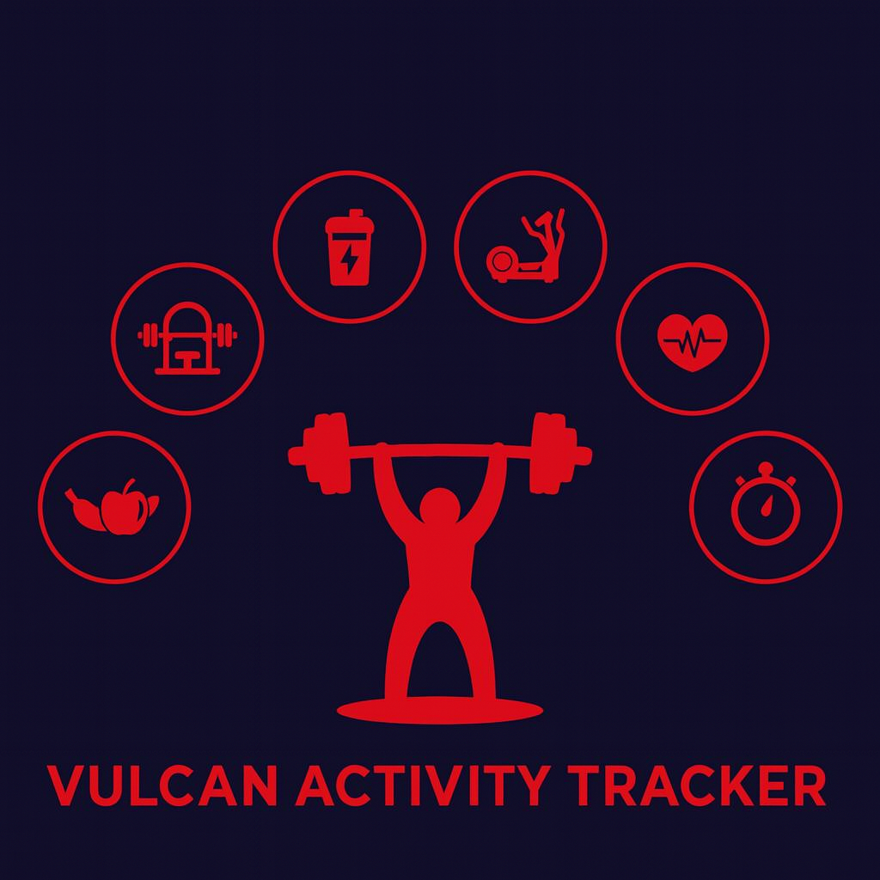

Week 10
Team Members:
Margo Bonal
John Gerega
Luke Ruffing

Professor: Dr. Weifeng Chen

Course: CMSC-4920-Senior Project II
School: Pennsylvania Western University

Table of Contents

Project: Vulcan Activity Tracker 2
Goals Accomplished: 2
Challenges Faced: 3
Team Progress: 4
Gantt Chart: 5
Week 11 Plan: 5
Member Contribution: 6

Project: Vulcan Activity Tracker
To complete the proposed goals in previous week’s report, our team followed a strict schedule of daily progress and communication. Our team had 3 main goals to complete, which was to focus on developing the teams page further, continue the user profile section, add some and frontend development on new pages. Since each goal needed time allocation for development and testing, we assigned each goal priority based on how they were connected to each other. Throughout the discussion, we decided that progressing the teams page was an important goal, as progress on it has stalled in recent weeks. Achieving this goal will help us progress into having a finished product.

Goals Accomplished:
The first goal accomplished was the continued development of the teams page. There were some hurdles on the way, but progress was made nonetheless. The user can view two of the team pages now, men’s soccer and men’s basketball. The templates for every team page will be the same moving forward, and right now, there is only test data on the two pages that do work.
The second goal accomplished was enhanced frontend features on the user profile page. We added sections that display the user’s username, email, account type, and status. We also added a quick stats section for quick glance. The formatting of the site can use some work, but it is an improvement from the only things on the page being change username and delete account
The third goal accomplished this week was the addition of a frontend search bar to the training page. This feature allows users to be able to quickly find activities by name. Although simple the search bar enhances usability by making it easier for users to find certain activities.

The fourth goal accomplished this week was frontend changes onto the leaderboard page. The changes helped improve the overall layout of the leaderboard page making it easier for user to filter the leaderboard for specific sports and metrics. These change while completely cosmetic are very important progress towards a polished user friendly experience with the activity tracker.
The Fifth and most notable accomplishment this week was our update to our servers architecture by moving from Flasks development server to Gunicorn. This change is a very important step of turning our developmental server into a launch ready website. Gunicorn provides a more stable environment for our application to run, as a result our platform is now much closer to deployment.

Challenges Faced:
(Number aligns with its solution below)
- Teams Page Development – we struggled to implement the verification of whether the current user was a coach or team member of the team. This was not allowing us to get into the page to view how it looked or how anything could possibly be connected to the backend. This was causing frustration as this page was the least developed going into the week. We also struggled to get the page working for every team, as our database currently contains empty tables for the teams and team members, so nothing can retrieved from the backend since there is nothing to retrieve.
- User Profile Functions – With the frontend features we added, there was some backend data we needed to retrieve. With a focus on teams this past week, this feature proved hard to complete. We also discovered a bug that a user cannot delete their account immediately after changing their username without first refreshing the page.

Solutions:
1. We decided to hard-code some test data to get into the team’s page and view how everything looked. This gave us exactly what we needed to complete the next steps for the teams page development. We can now populate our tables with actual team data, and then begin to ensure that the user cannot enter the teams page unless they are a member or a coach of that team.
2. The first challenge in the profile page was not completed but this week, but it just needs to retrieve the current user’s username and email to display on their profile. We also will need to call a couple of routes to display the quick statistics shown in the quick stats box.

Team Progress:
Throughout week 10 our team has made substantial progress to the Vulcan Activity Tracker. According to our Gantt chart our team is still on schedule for many parts of the project. It was very important to our team to keep working on the teams page. We feel that this page development is crucial to staying on track. Along with the further development of the teams page, we also added to the frontend UI/UX of both the training and the leaderboard pages. Which move us much closer to the polished look of our tracker that we want. Another major step made this week to the tracker was the server arcitecture conversion from Flask to Gunicorn. Which gives a much more stable and efficient enviroment to develop our activity tracker in, and gets us more prepared to integrate with Azure Web Hosting for launch. Each member provided valuable and crucial development, research, and debugging during this week.

Gantt Chart:
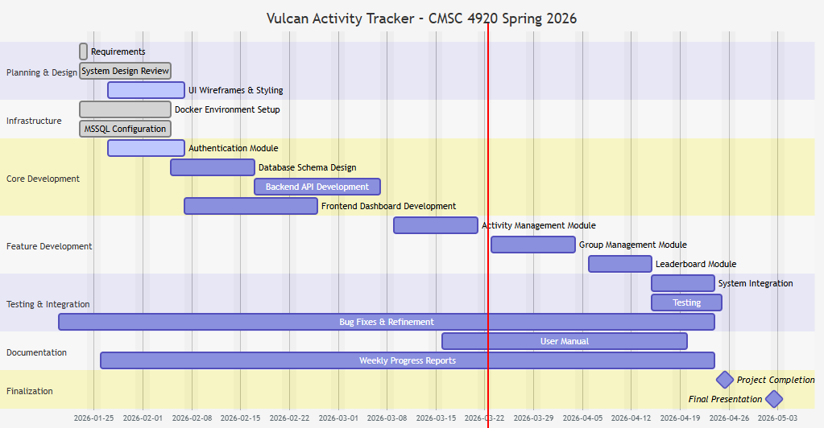

Week 11 Plan:
Our week 11 plan is going to focus on further development of the teams page. We also want to continue to improve pages, with some of them still having minor bugs in them, like the User Profile page. The final goal of the week will be continuing frontend development in general, as some of the pages are not developed to match the format of the trackers. Continuous checks will also will be performed to ensure that our project is properly aligned with last semester’s documentation. With less than 5 weeks left of the Senior Spring semester, our team moves forward with motivation to finalize features, add remaining components, and begin the platform hosting process!

Member Contribution:

Team Members
Margo Bonal: | - Team meetings, Week 10 Report & Slides, Website development, hosting research, leaderboard redesign, activity search
John Gerega: | - Team meetings, Week 10 report and slides, teams page, user profile page
Luke Ruffing: | - Team meeting, Week 10 Report & Slides, Challenges page

